HCLTech Hackathon Submission - HCLTech OptiSEO Agent
Problem Statement
Updating metadata tags of a page using the Opal agent is currently a manual and time-consuming process. It requires specialized knowledge of SEO best practices and CMS operations, making it inefficient for large-scale content updates.
Users of this Tool: Content Authors & Editors, SEO Specialists, Digital Marketing Teams & Web Administrators

Justification of the Problem
Metadata plays a critical role in improving search engine visibility and user engagement. However, creating and updating metadata tags for web pages is often a tedious task that demands expertise. This slows down content publishing cycles and impacts SEO performance. Automating this process will significantly reduce effort, improve accuracy, and enhance overall productivity.

Process to Create the Outcome
- Develop HCLTech OptiSEO Agent
  - This agent accepts Page URL and Content ID as inputs.
  - It generates optimized metadata (title, description, keywords) using AI-driven SEO recommendations.
- Create Custom Tool: cms_seo_metadata_update
  - This tool integrates with the CMS.
  - It takes the generated metadata from OptiSEO Agent and updates the corresponding page item in the CMS automatically.
Workflow Overview:
Page URL + Content ID → OptiSEO Agent → Metadata Generation → cms_seo_metadata_update → CMS Update
Outcome: A fully automated solution that reduces manual effort, accelerates SEO optimization, and ensures consistent metadata quality across all pages.
Consumers/Users Benefiting:
- Content Authors & Editors – Reduce manual effort in creating SEO metadata.
- SEO Specialists – Automate repetitive tasks and ensure consistency.
- Digital Marketing Teams – Faster optimization for campaigns.
- Web Administrators – Simplify CMS updates without deep technical expertise.

Steps involved in development and execution
- Create new agent in Optimizely Opal HCLTech OptiSEO Agent
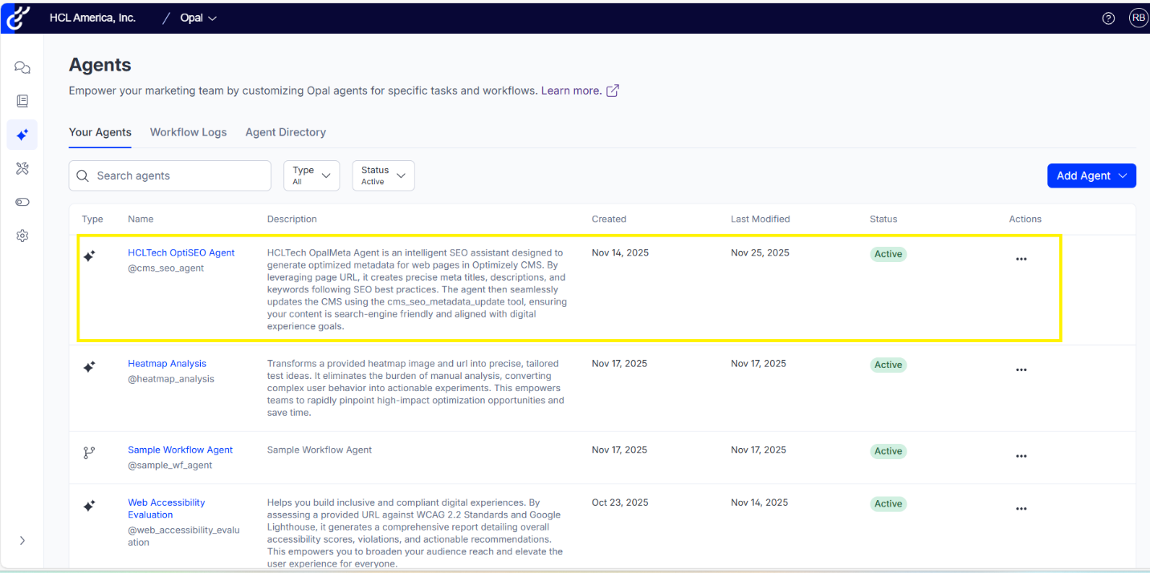

- Define Input parameters and pass the output to the custom tool cms_seo_metadata_update
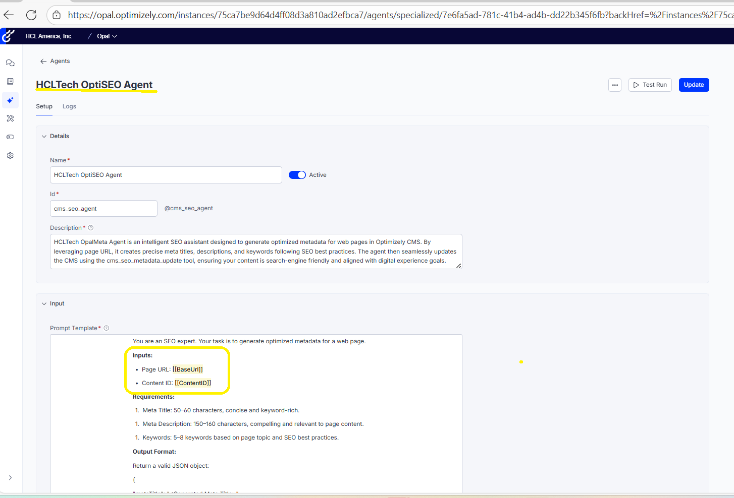

- Create custom tool cms_seo_metadata_update
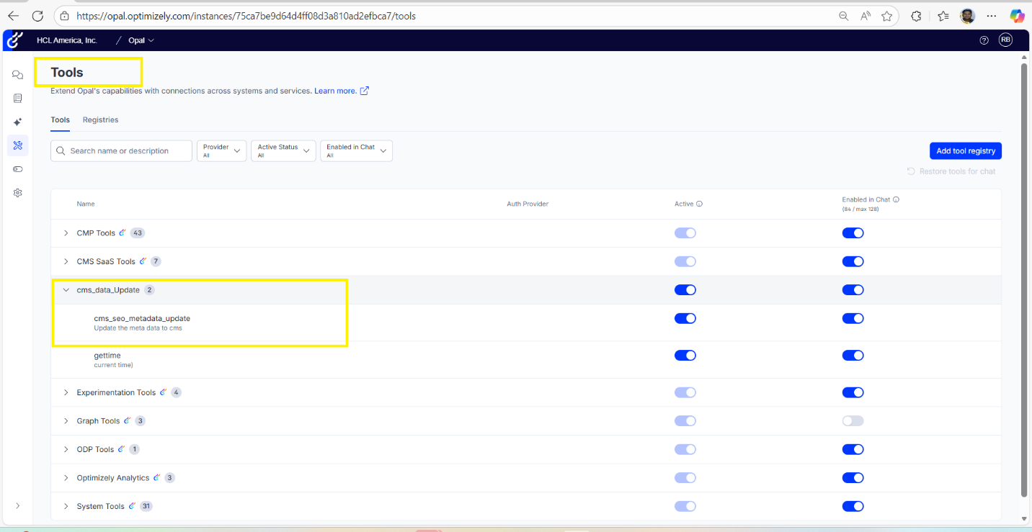

- Call the agent from CMS and update the metadata
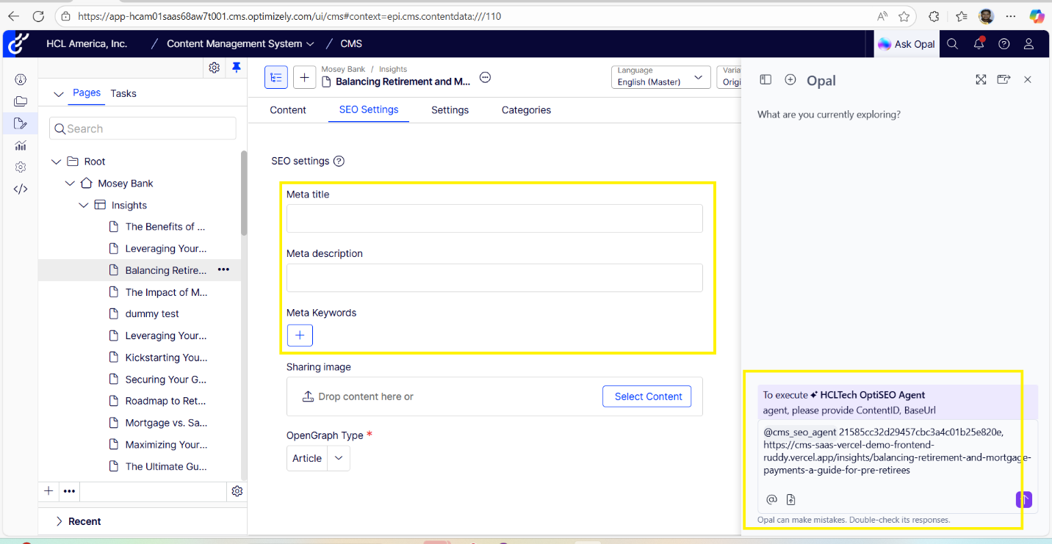

- Agent & Tool is called in the backend.
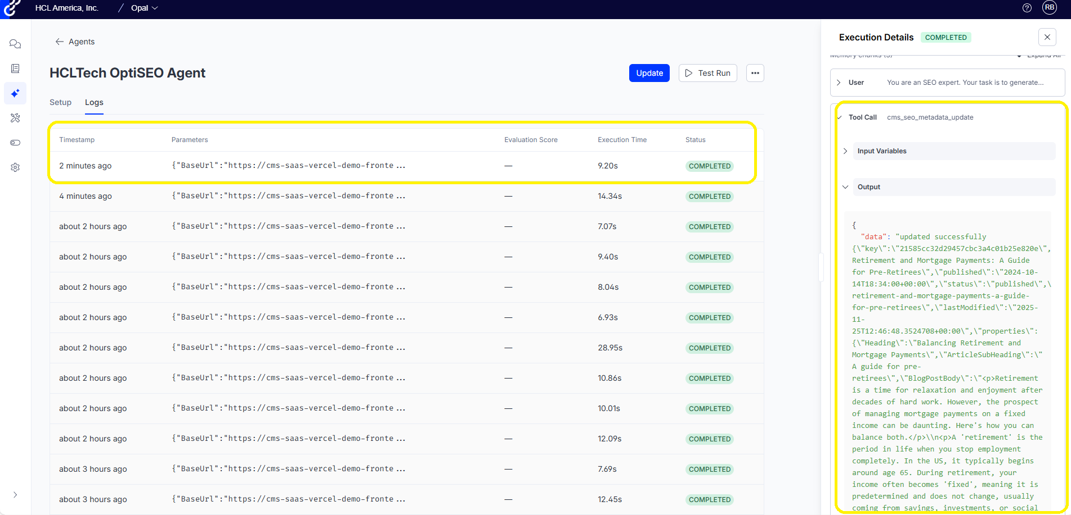
- Publicly hosted discovering URL: opalagent-cre6bafhaub8csaw.westus-01.azurewebsites.net/discovery
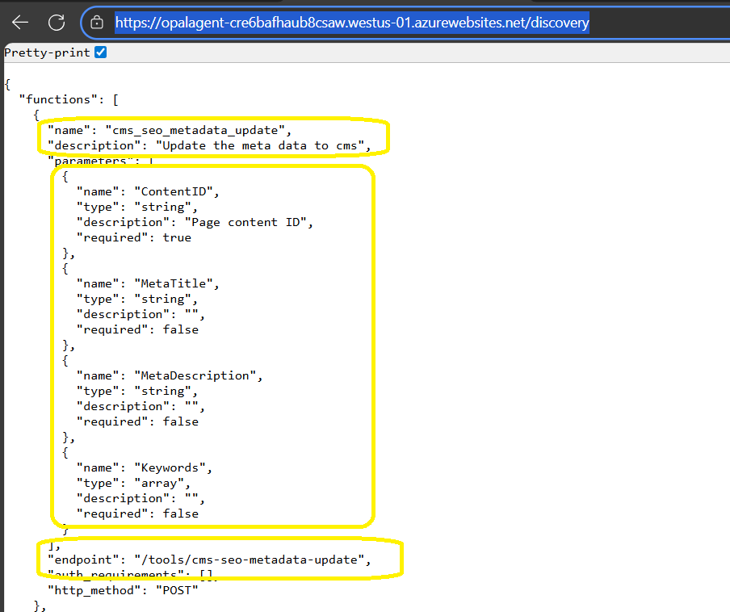
- Agent Guidelines:

